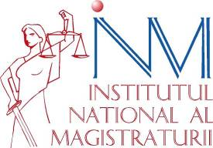

info day
In preparation for the 2016 DG Competition’s call for applications

13 NOVEMBER 2015
National Institute of Magistracy
(Regina Elisabeta Bulevard, No. 53)

ROOM 7TH, THIRD FLOOR

