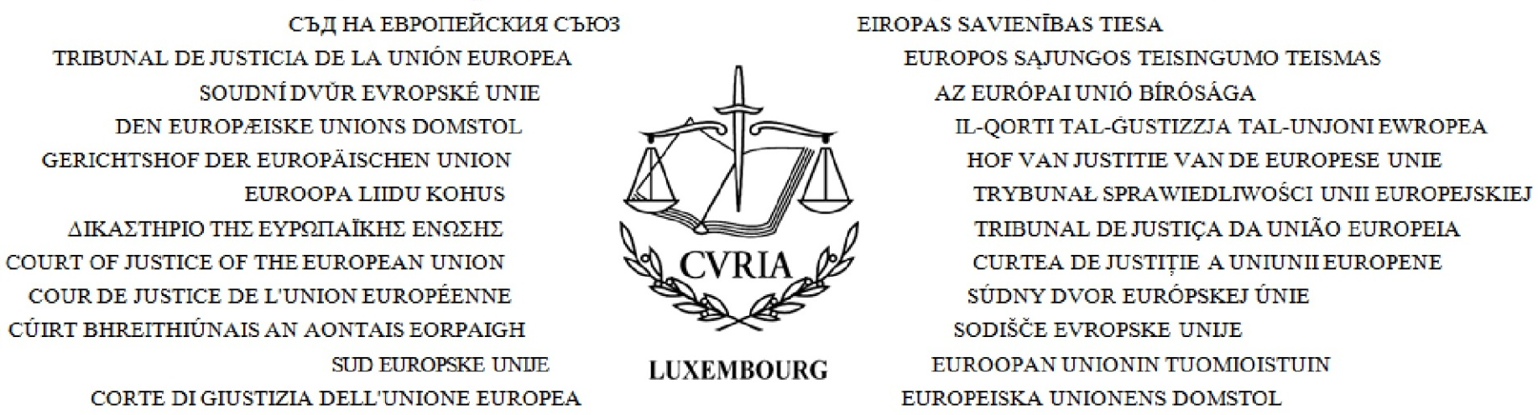
Directorate of Protocol and Information

Mrs Elena BLIDARU-MATEESCU ,
National Institute of Magistracy
53, Bd. Regina Elisabeta
050014 Bucharest
Romania
Luxembourg, 26/09/2014

Re:
Visit to the Court of Justice on 02/10/2014 - Vis/509-2014/pgm - Programme
Please find enclosed the programme for your visit to the Court of Justice.
Please would you be kind enough to take into account the serious difficulties regarding the traffic in Luxembourg which can be encountered in the morning, so that you can arrive on time and respect the programme for your visit in its entirety. If you would like to make any changes in the running of the programme which has been set out, we would like to thank you in advance for contacting the Visits service beforehand or the guide on the day itself, whose telephone number can be found on the programme.
We look forward to welcoming you to the Court.
Yours sincerely,
Court of Justice of the European Union
Directorate of Protocol and Information
Visits Service
L-2925 Luxembourg
Tel: +352 4303 3357 / Fax: +352 4303 3035 / e-mail: serv.visites@curia.europa.eu

Directorate of Protocol and Information | Luxembourg, 26/09/2014
VISIT OF 02/10/2014
Name of group: | National Institute of Magistracy
Name of person in charge: | Mrs E. Blidaru-Mateescu
Country of origin: | Romania
Working language: | Romanian
Number of visitors in the group: | 8
Guide: | I. Ruggeri (+352 621 90 23 10)
PROGRAMME
09:00 | VIP entrance - rue C. L. Hammes  Arrival

09:30 - 11:15 | Salle d'audience bleue  Hearing of case T-570/10 RENV (Environmental Manufacturing / OHMI - Wolf (Représentation d'une tête de loup) (EN) (Marque communautaire - Marque figurative représentant la tête d'un loup - Opposition du titulaire des marques figuratives internationales et nationales comportant les éléments verbaux "WOLF Jardin" et "Outils WOLF" - Refus d'enregistrement par la chambre de recours)

11:15 - 11:30 | Break

11:30 - 12:15 | Salle annexe à la salle de conférence - Ancien Palais niveau 2  General presentation about the Court of Justice with Mrs I. Radulescu, Legal Secretary, chambers of Judge Toader

12:30 - 13:00 | Meeting with with Mrs C. Toader, Judge at the Court  (bureau de Mme C. Toader, juge à la Cour)

13:00 | Salon E - Galerie - niveau 2  Buffet lunch provided by the Court in the presence of Mrs C. Toader, Judge at the Court, Mr A. Popescu, Judge at the General Court, Mrs I. Radulescu, Legal Secretary, chambers of Judge Toader, Mrs C. Prunaru, Administrator, Directorate for Research and Documentation and Mrs E. Csiki, Assistant, Library Directorate

14:15 - 14:45 | Salle annexe à la salle de conférence - Ancien Palais niveau 2  Meeting with with Mr A. Popescu, Judge at the General Court

14:45 - 15:15 | Salle annexe à la salle de conférence - Ancien Palais niveau 2  Round table with the participation of Mr L. Brinzoiu, Lawyer Linguist, Romanian Translation Unit, Mrs I. Danceanu, Lawyer Linguist, Romanian Translation Unit et Mr C. Ecedi-Stoisavlevici, Lawyer Linguist, Romanian Translation Unit

15:15 - 16:00 | Salle annexe à la salle de conférence - Ancien Palais niveau 2  Meeting with with Mrs C. Prunaru, Administrator, Directorate for Research and Documentation et Mrs E. Csiki, Assistant, Library Directorate

16:00 - 16:45 | Guided tour of the Court's buildings

16:45 | End of programme

