Group 1 – Monday COUNCIL room/1st floor, Tuesday COUNCIL room/1st floor,

Wednesday Seminar room no. 8/3rd floor,

Thursday Seminar room no. 8/3rd floor,

Friday MOCK TRIAL room/1st floor

& Group 2 - MOCK TRIAL room/1st floor

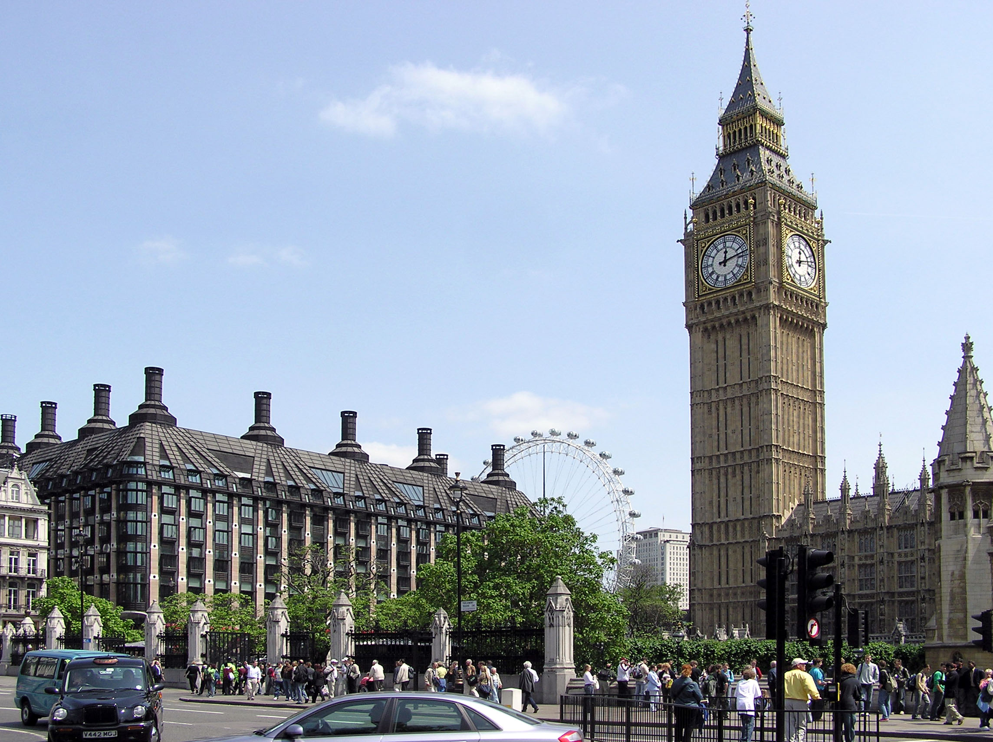

Training Seminar

BUCHAREST, NOVEMBER 10th – 14th 2014

Legal English